 | Pathways  A Weekly Collection of Information, Thoughts, Reflections and Accolades for the Reading Public School Community
December 14, 2014 | Volume 6, Number 17
Upcoming Dates  - December 15 – (2:45 p.m.) Parker Musical Auditions; (3:15 p.m.) Expanding the Boundaries in the Superintendent’s Conference Room; (7:00 p.m.) School Committee Meeting in Superintendent’s Conference Room; Wood End Winter Concert  - December 16 – (2:30 p.m.) RMHS Select Chorus Rehearsal; (2:45 p.m.) Parker Musical Auditions; (6:30 p.m.) RISE Parent Information Offering – How to help your child love books and reading  - December 17 – (1:30 p.m.) Secondary Building Meetings; (7:00 p.m.) RMHS Band Winter Concert in Endslow PAC  - December 18 – (2:45 p.m.) Parker Musical Auditions; (3:00 p.m.) Elementary Building Meetings; (4:00 p.m.) RETELL Session 10 in Distance Learning Room; (7:00 p.m.) RMHS Choral Department’s Winter Songfest in the Endslow PAC  - December 19 – (6:00 p.m.) RMHS Select Chorus Caroling  - December 20 - (6:00 p.m.) RMHS Select Chorus Caroling  - December 22 - (3:15 p.m.) Expanding the Boundaries in the Superintendent’s Conference Room; (7:00 p.m.) School Committee Meeting in Superintendent’s Conference Room;  - December 24 – Winter Breaks Begins  Kudos and Accolades  - To all staff and parents who participated in the Coolidge and High School Challenge Day activities. Thank you for taking time out of your busy schedules to participate in this important activity with students. Special thanks goes to Coolidge School Adjustment Counselor Marlene Lifshin and RMHS Director of Guidance Lynna Williams for coordinating these events at their respective schools.  Quote of the Week….    “Do the right thing, it will gratify some people and astonish the rest.”  Mark Twain  Disney Tweet of the Week    “You can stay in here and hope for a miracle, or you can get out there and make a miracle of your own.”  Laverne (Hunchback of Notre Dame II)  Contact Us  The Journey newsletter is published weekly for the Reading Public School Community . If you have anything that you would like to share, please email your information to John Doherty at  john.doherty@reading.k12.ma.us | More on Teen Sleep Deprivation  In this article in Principal Leadership, Saara Myrene Raappana sums up the accumulating research on the deleterious effect of sleep deprivation on teenagers and reports that only 15 percent of U.S. teens get the recommended minimum of eight and a half hours on school nights. The impact:  - Athletic performance – Studies of football players, swimmers, and tennis players have shown that getting an ideal amount of sleep improves athletic performance and stamina and reduces fatigue.  - Attention span – The NYU Sleep Disorders Program has found that inadequate sleep can result in children displaying hyperactivity, inattention, and impulsiveness.  - Bodily health – Proper sleep is linked to reduced inflammation, healthier weight, better cardiovascular health, and a longer life span.  - Creativity – The emotional elements of new memories are bolstered during sleep, which may stimulate the creative process, according to a Harvard study.  - Driver safety – Driving when sleep-deprived is even more dangerous than driving drunk, according to a 2009 report from the National Highway Traffic Safety Administration. One night of insufficient sleep is equivalent to one alcoholic drink.  - Grades and test scores – Numerous studies have shown that students with impaired or irregular sleep perform more poorly on tests and have lower grades than those who get enough sleep.  - Memory – Consolidation occurs during sleep, which strengthens memories and helps “practice” skills.  - Mental health – Sleep reduces stress levels, decreases anxiety, and can play a part in alleviating symptoms of depression.  There does seem to be a national trend toward later high-school start times: since 2012, high schools in California, Oklahoma, Georgia, and New York have pushed their start times later, joining Connecticut, North Carolina, Kentucky, and Minnesota.  “Let Them Hit Snooze” by Saara Myrene Raappana in Principal Leadership, December 2014 (Vol. 15, #4, p. 14-15), http://www.nassp.org/Knowledge-Center/Publications/Principal-Leadership. Reprinted from Marshall Memo 564  The Best Ways to Prepare Students for Common Core Reading Tests  In this article in The Reading Teacher, Timothy Shanahan (University of Illinois/ Chicago) says the “data-driven” approach to improving reading achievement – using item analyses to identify the skills students haven’t mastered and drilling test-aligned curriculum items – doesn’t work. Why? “Research long ago revealed an important fact about reading comprehension tests: they only measure a single factor…” says Shanahan: “reading comprehension. They don’t reveal students’ abilities to answer main idea questions, detail questions, inference questions, drawing conclusion questions, or anything else.” Having students practice answering questions on various reading subskills won’t produce better test scores. In fact, they may even depress reading achievement by wasting time that could be spent on productive activities.  Shanahan believes there are two reasons traditional standardized reading tests fail to produce useful data on subskills:  • First, reading is a language activity, not the execution of various subskills. To make sense of a text, students must simultaneously use a hierarchy of language features. When a student answers a main-idea question incorrectly, it doesn’t mean the main-idea part of the student’s brain isn’t working. Here are some possible explanations:  - The passage looked too hard and the student didn’t have the confidence to read it all the way through.  - The student is a slow reader and didn’t read far enough to grasp the main idea.  - The student’s decoding skills are weak and a lot of important words weren’t understood.  - The main idea was embedded in a particularly complex sentence, and although the student understood the rest of the text, this sentence wasn’t understood.  - The text had a lot of synonyms and pronouns and the student wasn’t able to form a coherent idea of what it was all about.  So what does explain students’ performance on standardized tests? Text complexity, says Shanahan: “[I]f the text is easy enough, students can answer any type of question, and if the text is complicated enough, they will struggle with even the supposedly easiest types of questions. That means reading comprehension tests measure how well students read texts, not how well they execute particular reading skills…”  • Second, reading tests are designed to separate proficient from struggling readers. To achieve this and create reliable tests, psychometricians reject questions that don’t have the best properties. “Test designers are satisfied by being able to determine how well students read and by arraying students along a valid reading comprehension scale,” says Shanahan. “They know that the items collectively assess reading comprehension, but that separately – or in small sets of items aimed at particular kinds of information – the items can tell us nothing meaningful about how well students can read.”  Won’t the innovative tests being created by PARCC and Smarter Balanced do a better job? Not at producing useful data on subskills, says Shanahan. “These new tests won’t be able to alter the nature of reading comprehension or the technical requirements for developing reliable test instruments.” The simple reason is that they can’t be long and fine-grained enough. So does that mean the PARCC and Smarter Balanced tests will be useless to educators and parents? Not at all, says Shanahan: “These tests will ask students to read extensive amounts of literary and informational text, to answer meaningful questions about these texts, and to provide explanations of their answers. These tests should do a pretty good job of showing how well students can read and comprehend challenging texts without teacher support.”  So how should we prepare students to do well on the new tests – and be prepared for college and career success? Not by focusing instruction on question types, says Shanahan – instead, by striving to make students “sophisticated and powerful readers.” Here’s how:  • Have students read extensively within lessons – not free reading, but reading that is an integral part of instruction, with students frequently held accountable for understanding and gaining knowledge. Round-robin oral reading is highly inefficient, says Shanahan. “Teachers like it because it provides control and it lets them observe how well a student is reading, but a reading comprehension lesson, except with the youngest children, should emphasize silent reading – and lots of it.” And this should also be happening in social studies, science, and math classes.  • Have students read increasing amounts of text without guidance and support. Many reading lessons involve students reading a paragraph or a page followed by teacher questions and group discussion. “This model is not a bad one,” says Shanahan. “It allows teachers to focus students’ attention on key parts of the text and to sustain attention throughout. However, the stopping points need to be progressively spread out over time… Increasing student stamina and independence in this way should be a goal of every reading teacher.” It’s noteworthy that the shortest prototype that PARCC and SBAC have released so far is 550 words long.  • Make sure the texts are rich in content and sufficiently challenging. “Lots of reading of easy text will not adequately prepare students for dealing with difficult text,” says Shanahan. They need to be reading grade-level texts with gradually decreasing teacher scaffolding around vocabulary, sentence grammar, text structure, and concepts needed to reach target levels.  • Have students explain their answers and provide text evidence supporting their claims. This is an important part of increasing intellectual depth and constantly moving students toward reading more-challenging material.  • Engage students in writing about text. Writing does a much better job of improving reading comprehension than answering multiple-choice questions, says Shanahan: “Although writing text summaries and syntheses may not look like the tests students are being prepared for, this kind of activity should provide the most powerful and productive kind of preparation.”  “How and How Not to Prepare Students for the New Tests” by Timothy Shanahan in The Reading Teacher, November 2014 (Vol. 68, #3, p. 184-188), http://bit.ly/1wr4JOa; Shanahan can be reached at shanahan@uic.edu.  Reprinted from Marshall Memo 564.  Six Important Common Core Shifts in Math  In this Educational Leadership article, Linda Griffin and David Ward (Lewis and Clark University) say that successful implementation of Common Core math standards hinges on teachers understanding five significant shifts:  • The equal sign (1.OA.D.7) – A common student misconception is that = is shorthand for “the answer is” – a prompt to solve the problem and write the correct answer. The meaning that students need to internalize in the early grades is subtly different: = expresses a relationship between quantities on either side, shorthand for “is the same as.” This lays the groundwork for future mathematical learning, especially in algebra (x + 5 = 11), opening the door to new strategies for solving complex problems. Griffin and Ward suggest that elementary teachers explicitly teach several synonyms for the equal sign (is the same as, has the same value as, balances, is worth the same), use a drawing of a balance scale or teeter-totter as a visual reminder, and vary the position of the solution blanks in number problems.  • Cardinality (K.CC.B.4) – A kindergarten girl is asked to count five cubes and correctly touches each one, saying, “One, two, three, four, five.” The teacher can tell if the child understands cardinality by asking how many cubes there are. If the child says “Five,” she understands. If she starts counting again, she hasn’t yet grasped that the last number has a special meaning – the number of objects in the set. This gives meaning to the counting process and opens the door to addition and subtraction solutions. It’s important for primary-grade teachers to follow up counting tasks by asking how many – for example, “How many children ordered hot lunch today?” Teachers can also encourage students to use counting as a strategy to solve more-complex problems – for example, “How many would we have if we combined these two piles of cubes?” or “How many pencils would you have if I took two out of your basket?”  • Properties (in several Common Core grade 1 and 2 standards) – Griffin and Ward suggest putting less emphasis on terms and abstractions (commutative and associative) and more on using them to make good strategic decisions to solve problems – for example, rearranging the numbers in the problem 6 + 7 + 4 into 7 + 6 + 4 makes the problem much easier to solve (adding 6 + 4 to make ten and then adding the 7). “Students who develop a habit of mind for problem solving that includes reflection and planning ahead will be able to use this skill to great advantage throughout their mathematical careers,” they say. “Students without this capacity have a tendency to plunge headlong into every problem without first taking a step back to identify the goal and consider multiple solution paths.” One teaching strategy to build this skill is giving students several problems with the same number combination reversed (for example, 5+2 and 2+5) and drawing attention to students who see that they have the same value, providing a shortcut in future problems with bigger numbers.  • Composing and decomposing (these occur in six Common Core K-2 standards across three domains) – “Students who develop flexible thinking about numbers early in their schooling are poised to develop complex mathematical thinking as they progress through the grades,” say Griffin and Ward. “Students who can decompose and recompose numbers see many options when presented with a challenging computational problem.” For example, 27 + 19 becomes much easier when a student sees the three tens or the two twenties or the 25 and 10. Teachers should frequently get students breaking numbers down to simpler pieces and ask questions like, “If you take my number apart one way, you can see 25 and 25 and 5. If you take it apart another way, you can see 40 and 15. What’s my number?”  • Unknowns (1.OA.A1) – A standard results-unknown problem – Dina had 12 marbles. She gave her cousin 7 marbles. How many marbles does Dina have left? – lends itself to students using cubes, drawings, or fingers to solve. But putting the unknown in a different position makes the problem more complex and challenges students to generate and apply more-sophisticated problem-solving strategies:  - Dina had 12 marbles. She gave her cousin some marbles. Now Dina has 5 marbles. How many marbles did Dina give her cousin?  - Dina had some marbles. She gave her cousin 7 marbles. Now Dina has 5 marbles left. How many marbles did Dina have at the start?  Griffin and Ward suggest that teachers regularly give students problems with unknowns in varying positions and work on developing robust solution strategies.  “Teachable Moments in Math” by Linda Griffin and David Ward in Educational Leadership, December 2014/January 2015 (Vol. 72, #4, p. 34-40), http://bit.ly/1zFhK3S; the authors can be reached at lgriffin@lclark.edu and davidward@lclark.edu. Reprinted from Marshall Memo 564.  Reading Public School Happenings  Hour of Code  Schools across the country are currently participating in an activity called “Hour of Code”, a series of activities to engage students in computer science activities. Hour of code has been used by several classrooms in the Reading Public Schools through the website http://code.org/learn . In the first two photos below, students in Wood End teacher Ellen Commito’s class are doing some preliminary code activities prior to go online by creating a code for a robot to stack cups. In the third photo, a number of girls from Coolidge attended a live video chat with Jess Lee, one of the ambassador's for the Hour of Code, and the CEO of Polyvore. Coolidge was one of 7 schools in the country selected to participate in the video chat. Here is a link to the video recording: http://youtu.be/wXKPrtfaoi8 .  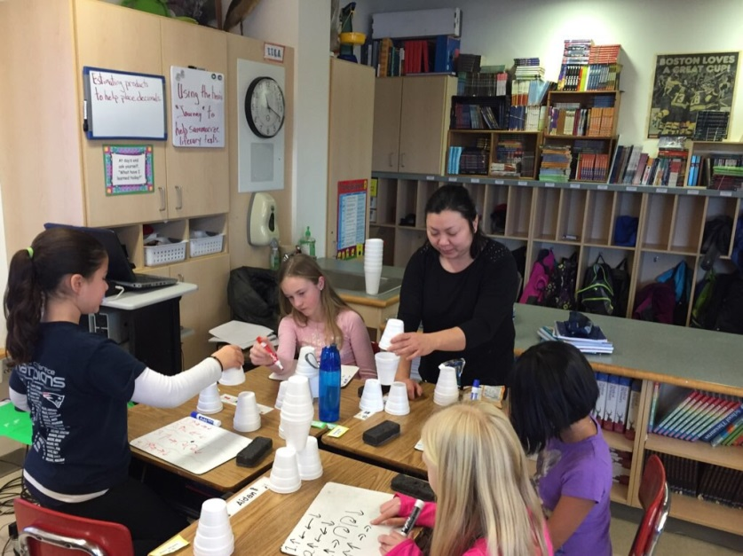  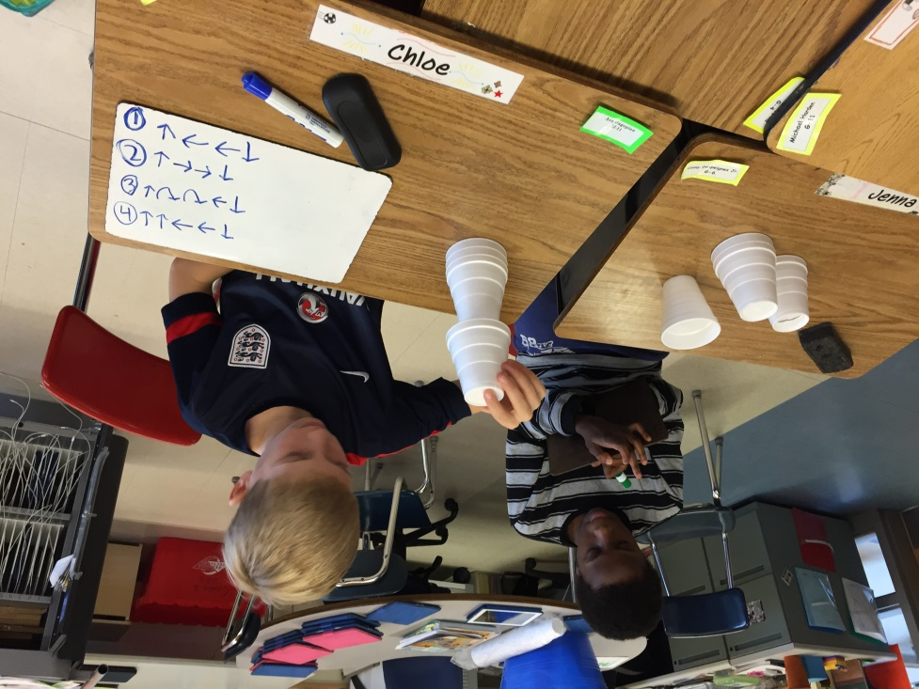  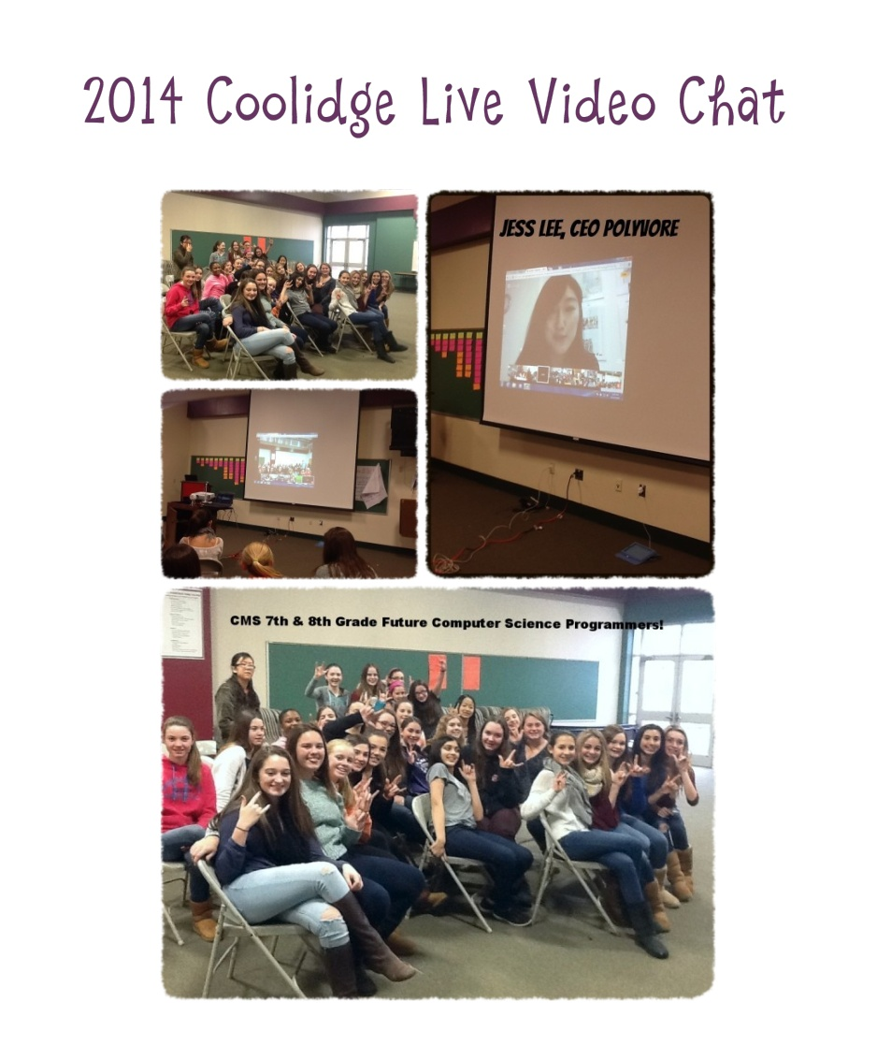  Festival of Trees  In the photo below, the Middle School Select Chorus, under the direction of Jennie DiMuzio sing at the Festival of Trees.  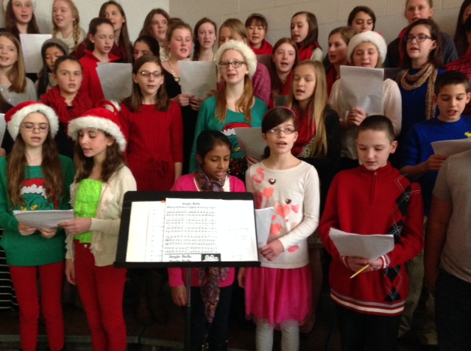  Stepping Stones….  - Congratulations to Facilities Secretary Darlene Porter on the birth of her granddaughters Kasey and Morgan on December 10 weighing in at 7 lbs.8 oz. and 7 lbs. 11 oz. and 21 inches long each.  - We welcome the following new hires to our school district:  - Nancy Ziemlak, Substitute, District  - Kelsey Finigan ,Special Education Paraeducator, Coolidge  - We have posted a position on School Spring. If interested, please visit  www.schoolspring.com to view the job details.  - The American Heart Association/The American Stroke Association is on a “Life is Why” mission. Their goal is to build healthier lives, free of cardiovascular diseases and stroke by getting the word out to schools and communities through their website: www.heart.org.  This link provides excellent resources on nutrition, exercise, stress management, healthier kids, as well as support for smoking cessation. Learn about heart disease, what your blood pressure numbers mean, how important your child’s blood pressure numbers are, and what they mean to your health.  Please visit the link for a “one stop shopping experience” on everything you need to know about Heart Health.  Blazing Trails….  "What Kind of Educator Are You?" Do you love data, or do you try to incorporate the latest gadget into your instruction? Are you motivated by seeing your students grow, or do you get excited by the chance to think outside the box? Take this ASCD quiz to find out what kind of teacher you are, and get three book recommendations that match your personality. Read More  "How Twitter Chats Can Help Educators Stay Connected." A group of Georgia educators hold a weekly Twitter chat to connect with colleagues and enhance professional learning. The educators exchange ideas on grading and other issues, and post transcripts and discussion topics on the group's website. Read More  "5 Free Resources for When An Elementary Teacher Needs 5 Minutes." There are issues that come up in a teacher's day that would take about five minutes to address, asserts kindergarten teacher Brian Smith. In this Scholastic blog post, he shares five free, online resources that can help give teachers in early-elementary classrooms the five minutes they need to do things such as call a parent and talk with an administrator. Read More  "A Therapist Goes to Middle School and Tries to Sit Still and Focus. She Can't." And neither can the students. This is a follow-up to two popular Washing Post posts about the problems kids face when they are forced to sit still in school for hours on end without a break. The post explains pediatric occupational therapist Angela Hanscom's experience and findings at a middle school she visited. Read More  "6 Rules to Break for Better, Deeper Learning Outcomes." Educators know when students tune in -- and also know when they tune out. The more elusive question is why. There is emerging consensus that the 20th Century approach to education, which favors methods such as lectures and rote learning, is standing in the way of making school relevant to more students. In this Edutopia blog post, author and educational strategist Monica Martinez shares six ways to break the rules of the 20th century's all-expansive curriculum where students "sit and get" and forge into 21st Century learning. Read More  "Students in Abu Dhabi Promote Inclusion with the 'Buddy Bench.'" When nine-year-old Tamara Khoury sees a fellow pupil sitting alone on a bench during break time, she and her friends spring into action in their Abu Dhabi school. Tamara, along with her fifth-grade colleagues Cynthia Stephan and Afra Al Ali, are members of Al Mushrif's Private School's anti-bullying council. Their job is to promote inclusion and extend a helping hand to any student who may feel left out, lonely or bullied. Read More  Have a Great Week!
  Full Day Kindergarten Teacher (Long-Term Substitute); Killam Elementary School | JOB ID# 1170962
  Grade 3 Teacher (Long-Term Substitute); Killam Elementary School | JOB ID #1170992
  Grade 3 Teacher (Long-Term Substitute); Killam Elementary School | JOB ID #1171022
  Computer Technician, Reading Public Schools | JOB ID #1183082

