 | Pathways  A Weekly Collection of Information, Thoughts, Reflections and Accolades for the Reading Public School Community
December 21, 2014 | Volume 1, Number 16
Upcoming Dates  - December 22 - (3:15 p.m.) Expanding the Boundaries in the Superintendent’s Conference Room; (7:00 p.m.) School Committee Meeting in Superintendent’s Conference Room;  - December 24 – Winter Breaks Begins  - January 5 – (3:15 p.m.) Expanding the Boundaries in the Superintendent’s Conference Room;  - January 6 – RMHS Guidance Alumni Day;  - January 7 – Grade 6 – 12 Early Release; (1:15 p.m. Elementary Building PLC; (1:30 p.m.) Secondry Building PLC; (1:30 p.m.); (RMHS Band – MENC Senior Districts in Lowell; (5:30 p.m.) Parker School Council; (7:00 p.m.) Parker PTO  - January 8 – (8:00 a.m.) Parker Daytime Parent Visitation; RISE @ Wood End Picture Retake; (3:15 p.m.) Elementary building PLC; (4:00 p.m.) RETELL Session 11 in Distance Learning Room; (7:00 p.m.) School Committee in the Superintendent’s Conference Room – FY16 Budget  - January 9 - (3:30 p.m.) RMHS Band – MENC Senior Districts in Lowell;  - January 10 - (9:00 p.m.) RMHS Band – MENC Senior Districts in Lowell; (5:30 p.m.) (10:00 a.m.) RMHS Drama Set Build/Safety Class  Kudos and Accolades  - To the RMHS Faculty and staff for the tremendous job that they did in working with students and staff who were grieving the loss of an RMHS student this past week. Your professionalism and attention to detail during this tragic event was welcoming and comforting to those who were grieving his loss.  - To the Girls Basketball, Girls Ice Hockey, Boys Track and Wrestling teams that all recorded their first wins of the season.  Quote of the Week….    “People don’t care how much you know until they know how much you care.”  John C. Maxwell  Disney Tweet of the Week    “Don’t stress over anything that you can’t change.”  Mickey Mouse  Contact Us  The Pathway newsletter is published weekly for the Reading Public School Community. If you have anything that you would like to share, please email your information to John Doherty at  john.doherty@reading.k12.ma.us | 2015-16 School Calendar Approved  At the December 15, 2014 School Committee Meeting, the Reading School Committee approved the 2015-16 School Year Calendar. The first day of school for students will be Wednesday, September 2, 2015 and the last day of school with four snow days built in will be Thursday, June 23rd. The school year will be adjusted accordingly depending upon how many snow days are used.  For the first time in several years, Rosh Hashanah, Yom Kippur, and Good Friday will all be school days. Last year, the Reading School Committee approved a Religious Accommodations Policy, IMDA, which puts practices in place to provide accommodations for students who celebrate different religious holidays. A copy of this policy and the school calendar are below.  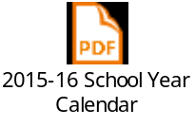    A Letter From Santa  By: Mike Gorman (http://21centuryedtech.wordpress.com/)  Dear Teachers,  I have been meaning to write this letter for a long time! It is a letter that I feel is long overdue and with the elves getting all ready for my long ride, I finally found the time! I have been watching teachers for many years and I am amazed at the work they do. I have come to a conclusion that the teaching profession, like my own, must be filled with bits of magic! Please let me provide ten statements of evidence for my belief.  - I travel the world one night of the year visiting all the boys and girls of the world. The teaching profession works with every boy and girl all year long. This equates to each teacher fulfilling educational needs for 30 – 200 children each and every school day. Seems like magic to me!  - I deliver presents to all the boys and girls. From my Toy Repair Shop statistics I find many of these gifts are broken or no longer garner a child’s interest within months! Yet teachers find inner gifts in every child. Teachers nurture these inner gifts until they develop into true presents that will last a lifetime. These kinds of gifts sure seem like magic to me!  - I keep my naughty and nice list for every child. Some people believe this job is pretty amazing! Yet when I look at the teaching profession, teachers provide a constant evaluation of all their students! Their list covers all the aspects of developing and learning which they report to children’s parents and to the children themselves! This evaluation is based on a wide variety of observations, data, and student performance. Teachers will then use this list to help improve each and every student! Wow, keeping track of every student’s ability and prescribing ways to be successful must really be magic!  - I leave presents to students who are on the nice list and who believe in me. Teachers work with all children because they believe in every student. Teachers continue to do so, even when students stop believing in the educational system’s ability to help them achieve. That type of persistence has got to be magic!  - I have operated my workshop using the same technology for hundreds of years and it has worked for me. Then again, I work with children when they are asleep, delivering presents in my own way. Teachers work with children when they are awake and they have spent time learning how to engage children using googles, blogs, phlogs, glogs, prezis, and all these other words I really don’t know! Being able to teach, transform, and accommodate for this new digital generation must really be magic!  - I have made it a practice to leave coal behind for children who do not make my good list! It seems every year the same children always get the coal. Teachers refuse to leave coal, in fact, they are working hard at leaving no child behind. To work towards a goal of leaving no child behind is a true act of magic!  - I read the news and I am always so thankful to read all the nice articles about my work. It really does provide me with motivation to keep up my vocation. I read news articles about the education profession and it seems that most articles are unsupportive. Yet, teachers keep working hard at providing success for their students! These teachers must be operating on a little bit of magic!  - I have thousands of elves, of course the reindeer, and the community of the entire North Pole to assist me. Teachers work every day, many times by themselves, as they provide new opportunities for their students! Carrying that load alone must be much heavier than my bag of toys. It must really be magic!  - I receive many a thank you and millions of pictures of happy faces as children open their presents each year. Teachers don’t always get the thank yous, or may never see the present get eventually opened. When they do, appreciation may come from decades later! A thank you that appears after many years must be the result of pure magic!  - I discovered a light in Rudolph brightens up a dark, foggy, or snowy night so that I can deliver joy to all the children across the world. Teachers provide the light that brightens our world in both the darkest night and brightest day! It is the light of learning and knowledge! The ability to keep that light burning bright must take a quite a bit of magic!  You see, I have found that magic does not come easily! It is made possible only by those who work hard and keep believing, and seek what they know is possible! As you can see, there must be a great deal of magic in the education profession! Please continue to keep this magic alive and know that you are all on my good list! After all, I had to learn all that I do from somewhere! So from across the years I know I have many teachers to thank! Last, to all teachers across the world… I really do believe in you!  Thanks for all the magic and what you do each and every day for children.  Santa  Reading Public School Happenings  Holiday Concerts  This past week the RMHS Band and Choral groups performed at their annual holiday concerts. The first three photos are the RMHS bands and ensembles performing under the direction of Dave Bunten and Joe Mulligan. In the second set of photos, the RMHS choral groups under the direction of Kristin Killian are performing. Kudos to all of the students for two exceptional nights of performances!  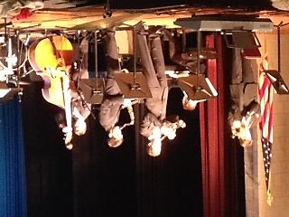    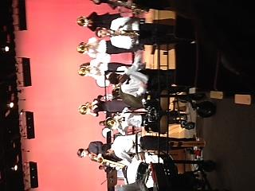  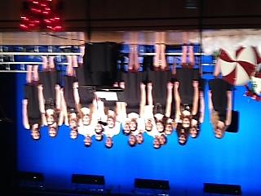  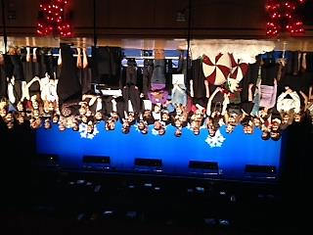    RMHS Singers Caroling  Over the last two weekends, the RMHS Singers have been caroling throughout Reading. In the photo below, the students are caroling traditional holiday songs at Portland Pie Restaurant downtown.  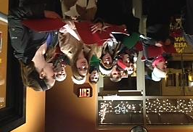  Parker World of Difference  Last week, several Grade 7 and 8 students from Parker Middle School participated in the World of Difference Peer Training. These students will be leading the next core values activity at Parker in January.  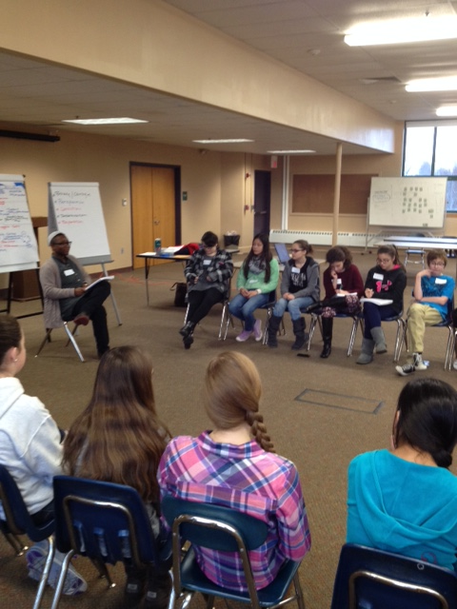  RMHS Singers at Dickens Faire  Last week, the RMHS Drama Club hosted the annual Dickens Craft Faire at Reading Memorial High School. This event features local performances and dozens of craft tables from the region. Below is a photo of the RMHS Singers performing at the Faire.  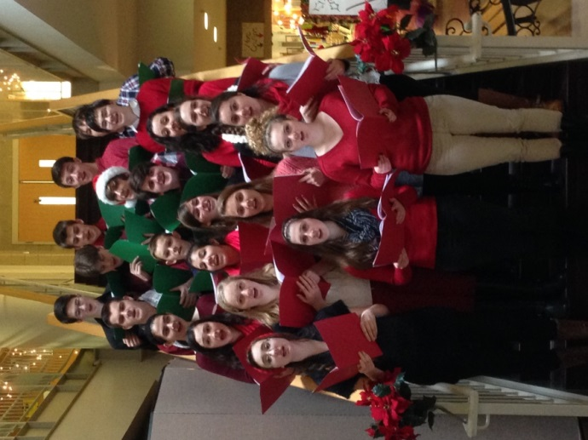  Stepping Stones….  - This past week, the Reading Community mourned the loss of RMHS Junior Nathaniel “Nate” Norman Doiron, who passed away last Sunday. Nate was an avid camper, Boy Scout, and in the past was a member of the RMHS band and wrestling team. He attended Barrows Elementary and Parker Middle School. Our thoughts and prayers go out to the Doiron family and the Reading Public School Community during this time of sorrow.  - We welcome the following new hires to our school district:  - Leslie Lougee, Substitute, District  - Tim Lane, Boys Assistant Track Coach, RMHS  - We have posted a position on School Spring. If interested, please visit  www.schoolspring.com to view the job details.  - PARCC Information Documents for Mathematics and Literacy- PARCC has released a set of test specification documents, including assessment blueprints and evidence statement tables, to help educators and the general public better understand the design of both the PARCC End of Year and Performance Based Assessments.  Mathematics-http://parcconline.org/mathematics-test-documents  Literacy-http://parcconline.org/ela-literacy-test-documents  - Free Graduate Courses-The Office of Tiered System of Support (OTSS) is pleased to announce that the application for the Spring 2015 Massachusetts FOCUS Academy (MFA) is now open. The MFA offers cost-free, on-line or hybrid, graduate courses in a variety of topics that provide educators and related service providers the skills, knowledge and strategies to meet the needs of all students, including those with disabilities, in safe and supportive, inclusive education environments. It is intended to address the DESE’s goals to have qualified educators in every public school classroom, to improve student outcomes, and to reduce achievement gaps. Participants in the courses receive 67.5 PDPs upon course completion and also have the option to purchase three (3), graduate level credits at a discounted rate through the partnering Institution of Higher Education (IHE), with which the course instructors are affiliated.  The Spring 2015 semester courses include:  - Assessment of Students with Disabilities who are English Language Learners (two face-to-face meetings at Lesley University)  - Collaborative Co-Teaching in the Inclusive Classroom  - Creating and Sustaining Positive, School-Wide Learning Environments (one face-to-face meeting at Fitchburg State University)  - Differentiated Instruction  - Mathematics for General and Special Educators: Content and Pedagogy (two face-to-face meetings at Fitchburg State University)  - Partnering with Families of Pre-School and Elementary School Students with Disabilities  - Partnering with Families of Middle and High School Students with Disabilities  - Universal Design for Learning (UDL): Addressing Learner Variability  - Universal Design for Learning (UDL): Addressing Learner Variability in Mathematics Instruction  - Universal Design for Learning (UDL): Student Affect and Engagement  The courses are open to all current educators in Massachusetts, although there are certain criteria that participants need to meet as outlined in the applications. Because Reading is a level 3 district, we receive priority to sign up for these courses. The application can be found at http://www.doe.mass.edu/mtss/ta/mfa.  Blazing Trails….  "Using the 'Grinch' to Help with Close Reading." Close reading is "a deeper examining/analyzing of a text through purposeful rereading," writes sixth-grade literacy teacher Rhonda Stewart. In this blog post, she shares a how-to guide she developed to complete a close-reading exercise of "How the Grinch Stole Christmas" by Dr. Seuss, and how the story fit with the curriculum themes in reading and writing workshops. Read More  "Why Math Might Be The Secret To School Success." Researchers of a new study are seeking to learn whether teaching math as early as preschool can help children improve later academic performance. The researchers are focusing on a math curriculum that emphasizes activities, such as identifying shapes and amounts, instead of rote learning. "We think math might be sort of a lever to improve outcomes for kids longer term," lead researcher Pamela Morris said. Read More  "The Secret to Ohio State's Offensive Football Success: An Unorthodox Method of Teaching." Ever since he arrived in Columbus three years ago, Ohio State football coach Urban Meyer has set about finding the most efficient ways to educate his players about the intricacies of his high-powered offense. What he hit upon is an approach that is increasingly popular in academic circles, but still mostly unheard of in the hidebound world of football coaching: flipping the classroom. In an effort to speed up the installation of his spread-option playbook-an offense that devastated defenses while Meyer was at Utah and Florida-Meyer decided to abandon old-school chalkboard sessions. Instead, he devoted team meetings to hands-on exercises, such as walking through plays and doing situational drills. Read More  "How Dissecting a Pencil Can Ignite Curiosity and Wonderment." "Thinking routines" are a series of activities that encourage students to closely observe, carefully consider and then discuss simple designs in their everyday world at a slow pace, researchers with the Harvard Graduate School of Education say. Kindergarten teacher Carla Aiello used a thinking routine called "parts, purpose, complexity" that encouraged her students to describe, dissect and even design their own pencils, which Aiello says has them approaching their schoolwork in new ways. Read More  "Schools Worldwide Participate in House of Code Event." The second annual Hour of Code event is being held this week during Computer Science Education Week, and officials say the goal is for as many as 30 million students to participate worldwide. Schools in the U.S. (including ones from Massachusetts) are among those participating, including some schools where older students are helping teach younger students how to code. Read More  Have a Happy, Healthy Holiday Season!
  Special Education Paraeducator (30 hours per week), Coolidge Middle School | JOB ID #1184212
  Middle School Math Teacher (Long-Term Substitute), Parker Middle School | JOB ID #1089942

