All are cordially invited to Celebrate

Martin Luther King Day

Monday, January 19th, 2014
9:30 Breakfast, 10:00 Program
Free & Open to all ages
Reading Memorial High School Performing Arts Center

“WE STAND TOGETHER FOR JUSTICE!”

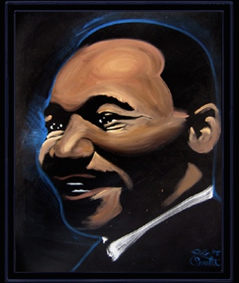
http://www.amazingheroart.com/NewFiles/g_mlk1.html

Featuring Community & School Musical Groups &
Amazing Hero Artist
Rob Surette

Hosted by the Human Relations Advisory Committee & Reading Public Schools
Made Possible By Generous Donations From
Reading Cultural Council, Moynihan Lumber


